

ICEcore QuickStart Guide

SiteScape Product Documentation

|  |  |
| --- | --- |
| Book Titlepage Text | April, 2007 |
| Book Version: | Version 1.0 |
| Software Version: | SiteScape ICEcore 1.0 |

Table of Contents

[Introduction 1](#_Toc165160182)

[Getting Started 2](#_Toc165160183)

[Find your way around with the Navigator 2](#_Toc165160184)

[Explore the Welcome portlet 3](#_Toc165160185)

[Buddy list 3](#_Toc165160186)

[Folder Bookmarks Portlet 4](#_Toc165160187)

[Configuring your workspace 4](#_Toc165160188)

[Add info and a photo to your profile 4](#_Toc165160189)

[Remove an image from your profile 4](#_Toc165160190)

[Creating Content 6](#_Toc165160191)

[Folder types 6](#_Toc165160192)

[Blogs 6](#_Toc165160193)

[Start a blog in your workspace 6](#_Toc165160194)

[Add your first blog entry 6](#_Toc165160195)

[Add a comment to a blog entry 7](#_Toc165160196)

[Rate an entry in a blog, wiki, or discussion 8](#_Toc165160197)

[Work with teams 8](#_Toc165160198)

[Use Favorites for places you visit often 12](#_Toc165160199)

[Tagging 13](#_Toc165160200)

[Relevance rankings 13](#_Toc165160201)

[Glossary 16](#_Toc165160202)

*The term “ICEcore” applies to all versions of ICEcore unless otherwise noted. For more information about ICEcore features, refer to the* ***ICEcore Quick Tips*** *sheet and to the online help.*

# Introduction

ICEcore is a collaborative software suite that runs in a web portal. It provides a rich set of tools that facilitate working in groups:

* Shared and private workspaces, with built-in versioning
* Real-time instant messaging and conferencing
* Collaborative authoring tools (wikis, blogs, and threaded discussions) with logging
* RSS and email subscriptions so users can be notified of updates
* Social networking features (tags, content ratings)

# Getting Started

When you first start using ICEcore, you will see four portlets: **ICEcore Navigator**, the **ICEcore Welcome** portlet, an empty **Buddy list** portlet, and an empty **Bookmarks** portlet.

## Find your way around with the Navigator

The **ICEcore Navigator** is your navigation center.

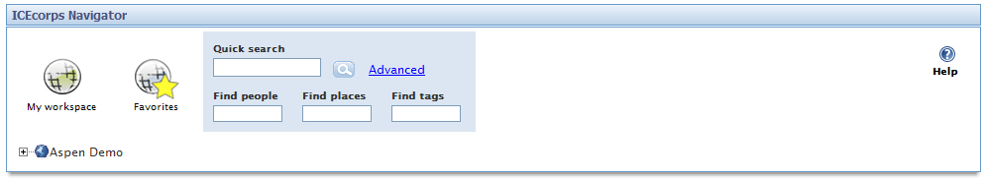

Using the tools here, you can navigate to anyplace that you need to go:

***My workspace icon.png My workspace*** Click to open your personal workspace, which contains your folders, your profile, your Guestbook, and your Dashboard.

***Favorites*** Click to open the **Favorites** menu, where you can add links to folders that you access frequently . From this menu, you can bookmark the current folder or workspace, navigate to any of the places that you bookmarked previously, and edit your bookmark list. (*See* *on page 12.)*



***Quick Search*** Enter any type of search term in the **Quick search** box and click Search icon.png to display a **Quick search** folder with the search results.

*For more search options, click* ***Advanced***.

***Find people, Find Places, Find tags*** Use these boxes to search for a user’s personal workspace, for a workspaces and folders, or for items with tags. (*See .*)

***Workspace Tree*** Click the plus sign to the left of the workspace tree icon Workspace Tree icon.pngto expand the workspace tree:

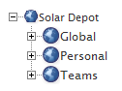

The tree has three main branches: **Global**, **Personal** and **Teams**. Expand one of these categories and “drill down” until you get to the workspace you need. To collapse a branch, click the minus sign to the left of the branch: Workspace Tree icon minus sign.png

Help icon.png ***Help*** Click to enter **Help mode**, then click on one of the help icons Help icon.png that appear to access context-sensitive help. To exit **Help mode**, click **Exit Help mode**, or click anywhere except on another help icon.

## Explore the Welcome portlet

The **Welcome** portlet provides links to ICEcore help topics and the ICEcore user guides in PDF format.

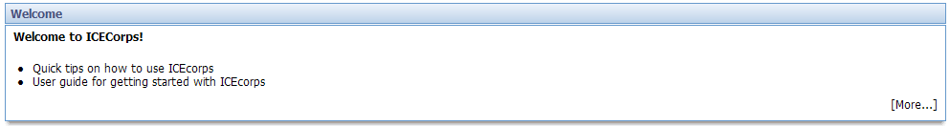

If you remove this portlet, you can get it back by clicking **Add Content** at the top of your screen and selecting **Welcome** from the **ICEcore** menu.

## Buddy list

Your **Buddy List** helps you keep track of people that you’ll need to contact frequently. Add people to your buddy list right away to make it easy to get in touch with them.

1. Click **Add buddies**.
2. Start typing a name in either the **Users** or the **Groups** box. A dropdown list displays matching names. Select a name and click **Apply** to add the name to your list.
3. Add as many names as you want, clicking **Apply** after each one.
4. To remove a name, click the **x** icon after the name; then click **Apply**.
5. When you finish, click **Close**.

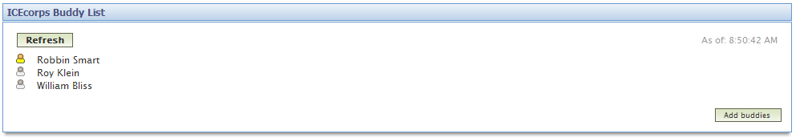

Tips for using your buddy list

* The icon to the left of a buddy name indicates *presence*.

|  |  |
| --- | --- |
| Presence_Online.png | Online |
| Presence_Online.png | Away |
| Presence_Online.png | Offline |
| Presence_Online.png | Unknown status |

* To communicate with a buddy, click his or her presence icon and select an option from the menu that appears.
* To update presence information, click **Refresh**.
* To view a buddy’s contact information or to navigate to his or her workspace, click the buddy’s name.

## Folder Bookmarks Portlet

The Folder bookmarks portlet is a tool to help you keep track of updates to important folders. You can select which folders you want to watch, and you can display the number of unread entries in each. This tool is displayed on the sign-in page, so you can attend to any issues in the displayed folders immediately. If there are unread entries, you can open the folder to read them by clicking the folder name:

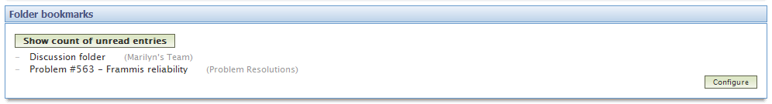

# Configuring your workspace

## Add info and a photo to your profile

1. In the Navigator, click My workspace icon.png **My workspace** to go to your personal workspace.
2. On the menu bar for your workspace, click **Modify profile**.
3. Fill in any missing information. This information is visible to others and is also used by ICEcore and Zon to contact you by phone, email, or instant messaging.
4. Add a picture. Click **Browse…** to look for a graphics file on your computer.
5. Click **OK** to close the form**.**

The information is updated, and the picture is displayed in the **Photo** box of your profile.

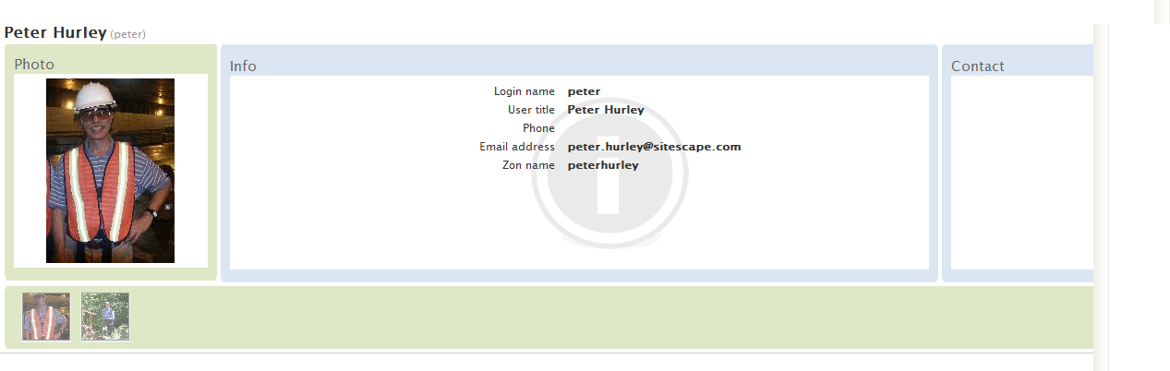

## Remove an image from your profile

1. To remove an image from your profile, click **Modify profile**.
2. Select the images to be deleted by clicking their check boxes.

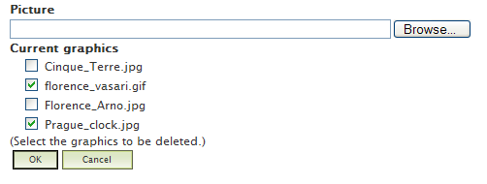

1. Click **OK**. The images are removed.

Tips for adding photos to your profile

* You can add as many images as you like, but you must add them one-by-one.
* Thumbnails of all of your images are displayed beneath your contact information. As you move the mouse over a thumbnail, the image is displayed in the **Photo** box. To replace the original image in the **Photo** box with one of your other images, click on the image thumbnail.
* To add a picture from the Internet, first save it to your computer.

# Creating Content

## Folder types

ICEcore workspaces can contain a wide range of content. A unique feature of ICEcore is that it provides a variety of folder types, each designed for a particular type of content. For example, ICEcore has specially designed folders for wikis, blogs, discussion forums, file folders, and calendars, to name just a few.

## Blogs

A blog is an online journal in whose entries are displayed in reverse chronological order (newest on top). It differs from wikis and discussion forums in that it generally written by a single author, with comments by members of his or her reading audience.

### Start a blog in your workspace

1. Click My workspace icon.png **My workspace** to display your personal workspace.
2. On the workspace menu bar, click **Manage this workspace**.
3. Select **Add new folder**. A form for adding a folder appears.
4. In the **Title** field, enter a title for your blog.
5. Under **Select a template**, choose **Blog folder**.

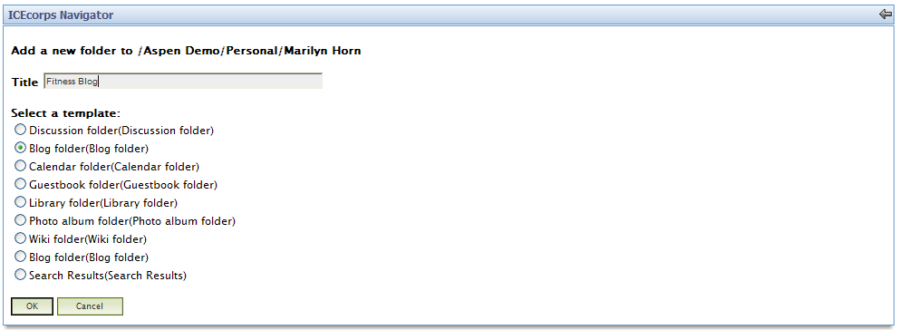

1. Click **OK** to create the blog.

## Add your first blog entry

1. On the menu bar above the blog calendar, click **New** and select **Blog entry**.

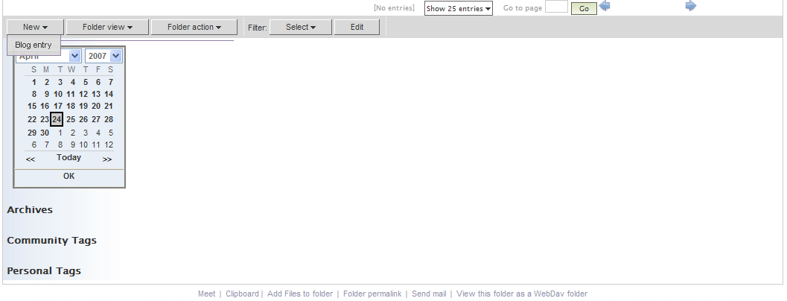

1. In the entry form that appears, enter the title of your blog entry in the **Title** box.
2. In the **Description** box, enter the content of your blog entry, using the rich formatting tools in the editor.

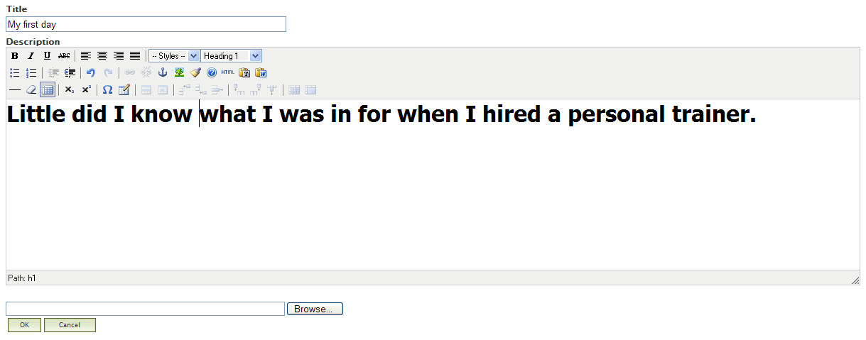

1. Click **OK** to add the entry to your blog.

## Add a comment to a blog entry

Comments are a way to give feedback to a blog author.

1. Click the Add comment icon.png icon beneath the blog entry.
2. In the form that appears, enter the title of your blog comment in the **Title** box.
3. Enter your comment in the **Description** box.
4. Click **OK**. Your comment will appear below the blog entry.

## Rate an entry in a blog, wiki, or discussion

Another way that readers can provide feedback to authors is to rate entries on a scale of 1 to 5. By rating entries, you are making it easier for other users to focus on the most useful content.

1. View an entry in a blog, wiki, or discussion folder
2. Drag the mouse over the rating stars above the entry to highlight the desired number of stars (1-5).
3. Click to register your rating. The average rating and the number of ratings are updated immediately.

Rating for entry.png

# Work with teams

ICEcore was designed to facilitate teamwork. Create a team workspace; then add folders and a team to the workspace. Once your team is set up, you can communicate easily with your team members.

Create a team workspace:

1. In the Navigator, click on the workspace tree to expand it.
2. Click on the **Teams** branch of the workspace tree.
3. On the **Teams** tab that appears, click **Manage this workspace**.

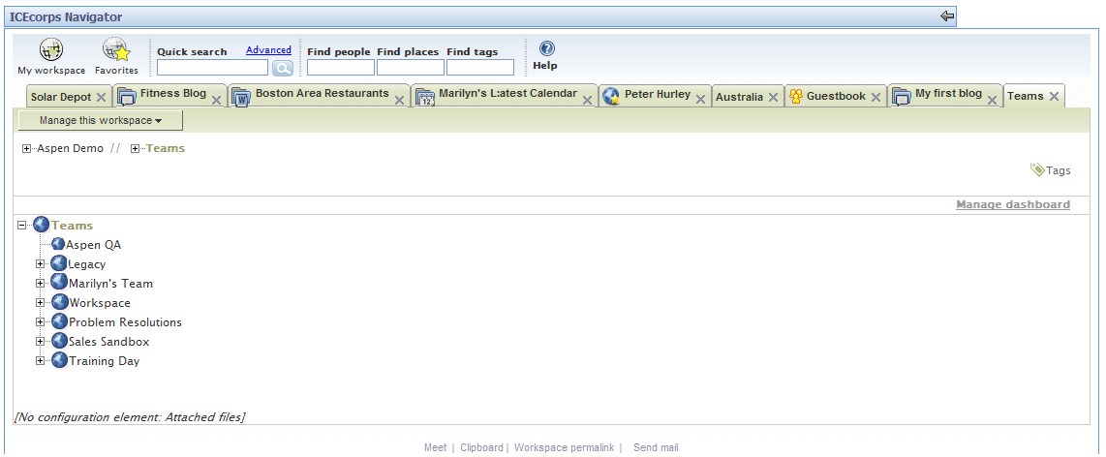

1. Select **Add new workspace**.
2. In the **Title** field, enter the name for your new workspace.
3. Click **OK**. The new workspace is added to **Teams**.

Add folders to the team workspace

For each folder that you want to add:

1. Click on **Manage this workspace**.
2. Click **Add new folder**.
3. In the form that appears, enter a name in the **Title** field and select the template for the folder that you want to add (Discussion, Blog folder, Calendar folder, etc.)
4. Click **OK**. The folder is added to the workspace.

Add a team to a workspace or folder:

1. On the tab for the folder or workspace, click **Access control**.

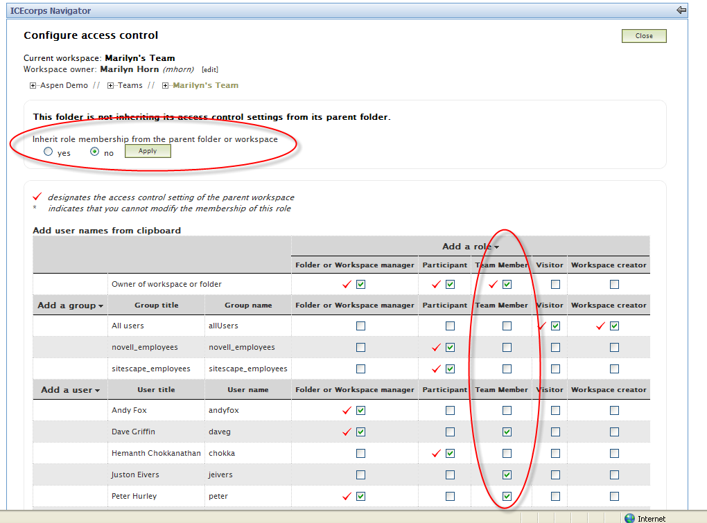

1. Change the setting for **Inherit role membership from the parent folder or workspace** to **No** and click **Apply**.
2. In the **Roles** table, select **Team Member** for every user (or group of users) that you want to add to the team.
3. If a user is not shown in the **Roles** table, click **Add a user**. Begin typing the user name and select the name from the dropdown list. Then click **Team Member** for that user.
4. When you have finished adding members, click **Save changes**, then **Close**.

View team members:

1. Select the workspace or folder with which the team is associated.
2. On the menu bar, click **Team**
3. Click **View members**.

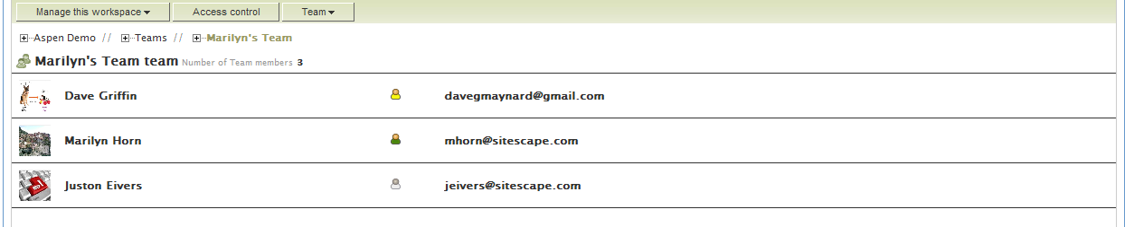

Notice that, as in your buddy list, presence icons are using to indicate the online and availability status of your team members.

Creating a team meeting:

1. On the menu bar, click **Team.**
2. Click **Create a meeting**. The Add meeting form will appear.

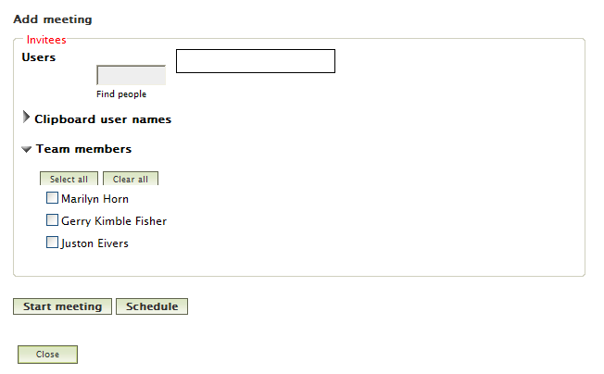

1. Click **Select all** to create a meeting with all team members, or select the individual members to invite.
2. Click **Start meeting** to start a meeting immediately, or click **Schedule** to arrange a meeting in the future.

Sending mail to your team:

1. On the menu bar, click **Team**
2. Click **Send mail to members**. The **Send email** form appears:

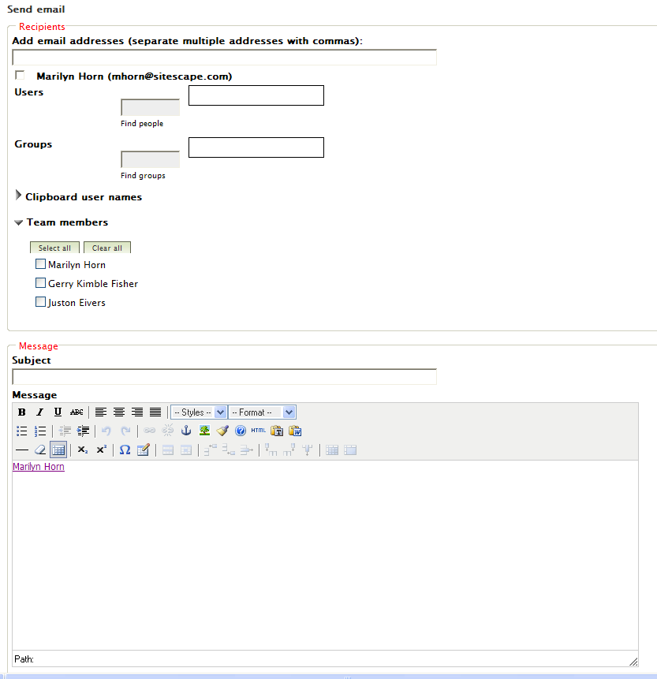

1. To send mail to all team members, click **Select all**.
2. Fill in the **Subject** and **Message**.
3. Click **OK** to send the message. The message will contain a link back to your workspace.

Tips for working with teams

When setting up teams, begin at the top-most workspace or folder. Then allow workspaces and folders below that to inherit role membership.

## Use Favorites for places you visit often

To add a place to Favorites:

1. Navigate to the workspace or folder that you want to add to your **Favorites** list.
2. ClickFavorites icon.pngto open the **Favorites** menu.

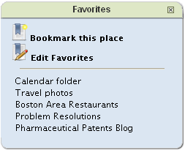

1. Click **Bookmark this place**. The workspace or folder is added at the end of the **Favorites** list.

To return to one of your Favorites:

1. ClickFavorites icon.png to open the **Favorites** menu.
2. Click on the name of a place that you previously added to the **Favorites** list.

To delete one or more Favorites from your list:

1. From the **Favorites** menu, click **Edit Favorites**.



1. Select each of the places to delete.
2. Click **Delete**, then **OK**. The places are removed from your **Favorites** list.
3. Close the **Favorites** menu.

To change the order of the items in your Favorites list:

1. From the **Favorites** menu, click **Edit Favorites**.
2. Select one or more items in the list.
3. Click **Down** or **Up** to move the selected items down or up.
4. When you finish, click **OK**.
5. Close the **Favorites** menu.

## Tagging

Tagging is a powerful way to discover, evaluate, and retrieve information. Users assign keywords, called tags, to workspaces, folders, and entries. Tags are designated as either community (shared) or personal (private). You can then use tags in searches. The search engine also uses tags to rank search results by relevance.

To add tags to a workspace, folder, or entry:

1. Start in the place that you want to tag. Any tags already assigned to this place are displayed below the Tags icon.png icon.
2. ClickTags icon.png to open the **Add/Delete Tags** form. Any previously assigned tags are also listed here.
3. In either the **Personal** tags or **Shared** tags text box, type the new tag and click Add. As you type, a dropdown list displays existing tags that match the letters in the box. When you click Add, the tag is added to the list of tags assigned to this place.
4. When you finish adding tags, close the **Add/Delete Tags** form by clicking the x in the upper right corner of the form. You will now see the new tags below the **Tags icon.png** icon.

To remove tags from a place:

1. ClickTags icon.png to open the **Add/Delete Tags** form.
2. Click **Delete** for every tag that you want to delete.
3. When you finish deleting tags, close the **Add/Delete Tags** form by clicking the x in the upper right corner of the form. The tags that you deleted are removed from the list of tags beneath theTags icon.png icon.

To use tags in a search:

1. In the **Find tags** box in the Navigator, start typing the personal or shared tag that you want to search for. As you type, a dropdown list displays tags that match the letters that you’ve typed.
2. Finish typing the tag (or select it from the list) and press **Enter**.

A new tab appears, containing a summary of every item to which the tag was assigned. You can skim the results, and open any items that look interesting.

## Relevance rankings

When you perform a **Quick** or **Advanced search**, the top-ranked places (folders) and people (authors) are displayed in descending order of popularity on the left side of the search results page. The brightness of the star to the left of an item in the list indicates the relative ranking of the place or author.

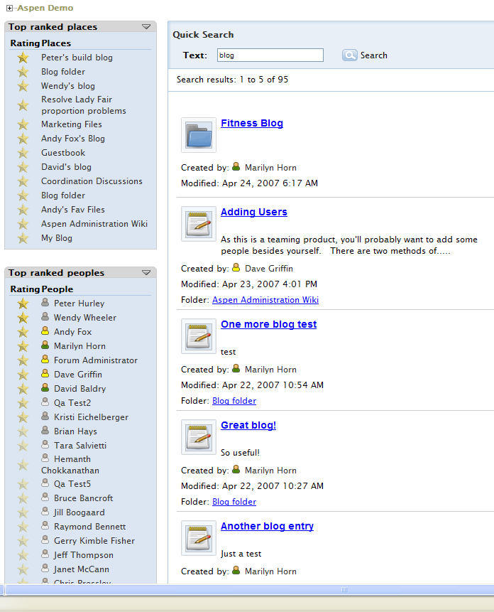

Tips for working with tags:

* Tags are case-sensitive. This means that Internet, internet, and INTERNET are all separate tags.
* Tags are single words that cannot contain punctuation marks, underscores, hyphens, or spaces.
* Avoid adding personal tags that are identical to shared tags. When you use **Find tags** to search for a personal tag that is the same as a shared tag, the search results will return both sets of items, which may be confusing.
* Use **Advanced Search** to:
* search for multiple tags
* use mixed search criteria (for example, to search by **Author** and by **Tags** in the same search)
* search only for shared tags or only for personal tags.
* The *tag cloud* (weighted list of tags) displayed in the **Quick Search** and **Advanced Search** results shows tags associated with the first 200 items returned by the search. The type size of the tags indicates their relative frequency of use.

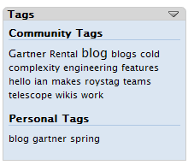

# Glossary

***buddy list*** A list of people that you contact frequently.

***entry*** An item, such as a wiki topic, file, or photo, that is contained in a folder.

***folder*** A container for entries and other folders. Each folder has a type, such as *blog*, *wiki*, or *calendar*, that determines its appearance and features.

***presence*** The state of being connected to a communications service and available for communication. Presence information is indicated by status icons.

***tag***  A keyword that anyone can add to a place to make it easier to find that and related places. *Community tags* are shared. *Personal tags* are private.

**tag cloud** A weighted list of tags in which frequently used tags are displayed in larger type.

***workspace*** A container for folders and other workspaces.